How to maintain Academic Integrity, avoid plagiarism and properly cite using Au Harvard
Name
Institution
Date

How to Avoid Plagiarism

Introduction
Plagiarism is an act of student using someone else’s information without citing or crediting them properly. It can occur deliberately when students copy someone’s work in parts or wholly. In other times, it occurs accidentally without students noticing. Plagiarism amount to academic dishonesty and thus the student should take all effort to avoid plagiarism as it can result to penalties, failure, and suspension from institution or other disciplinary actions.
Types of plagiarism
♦ Direct Plagiarism
♦ Self-Plagiarism
♦ Mosaic Plagiarism
♦ Accidental Plagiarism
Guidelines to avoid plagiarism
♦ Always note and record used sources
♦ Always quote properly by use of quotation or block quotation formatting and cite accordingly
♦ All used sources should be properly cited
♦ Ensure you use plagiarism checker to detect accidental plagiarisms
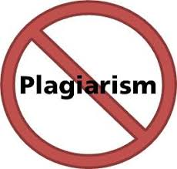
How to Uphold Academic Integrity
Introduction
Student should always maintain academic integrity and avoid cheating and ensure they get grade that matches their hard work and commitment (Raud, et al., 2018, 1374-1379). Students normally become dishonest willingly and aware of their dishonest act while at some instances, they might be unaware. For instance, they might be unable to use information from websites to write their work and thus get themselves being a victim of plagiarism. On the other hand, they may make poor decision due to time limit, unpreparedness and fear of failure.
NB: students should always Follow all rules during exams and when doing assignments during exams and when doing assignments

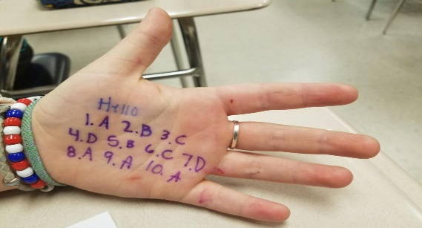

How to avoid academic dishonesty
Student should follow the following guidelines as outline by (Sariasih and Tisnawijaya, 2019, 12-50) to avoid academic dishonesty:
♦ Read the syllabus guidelines properly and avoid getting clarification from other students. In case of doubts, seek clarification from the instructor.
♦ Students should assume that the assignments given are personal unless the instructor has instructed otherwise. Clarification should come from the instructor about group assignment.
♦ Properly manage time. Avoid last minute rash that results to cheating and plagiarism. This can also give ample time for making clarifications from the instructor.
♦ Avoid sharing assignments with other students. However, students should help other to understand the concept rather than copying the assignment.
♦ Learn proper referencing and citation strategies to avoid plagiarism.
♦ In case of time limit, it is always advisable to seek time extension rather than copying.
♦ During exams, avoid sitting too close to other students to avoid being tempted to look at other students work
♦ Do not take any unauthorized written material to the exam room.

How to Reference Correctly Using Au Harvard Referencing
Citation is the acknowledging and crediting the source of information. It helps avoid plagiarism by giving credit on where the information has been acquired from. It also enables the reader to know the sources of information used and thus in case he wants to refer, it would be easier for him. In-text citation should always correspond to reference/ work cited page. Type of referencing styles includes MLA, APA, Chicago and Au Harvard Referencing. In Harvard the author, year or publication must be used in in-text referencing in the following format (Author last name Year, Page).

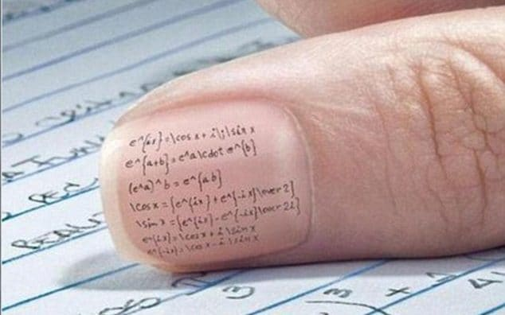

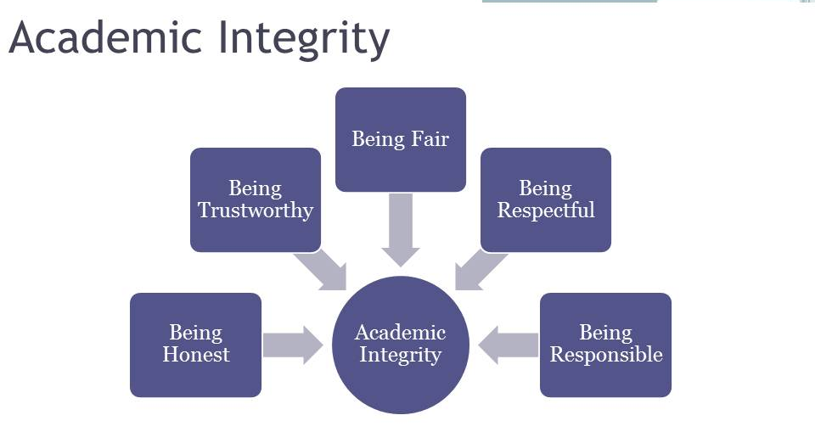

References

Raud, Z., Vodovozov, V., Serbin, A. and Petlenkov, E., 2018, April. Motivating students to avoid academic dishonesty in learning engineering courses. In 2018 IEEE Global Engineering Education Conference (EDUCON) (pp. 1374-1379). IEEE.
Sariasih, W. and Tisnawijaya, C., 2019, February. Academic dishonesty: How students do the learning assessment and project. In Sixth of International Conference on English Language and Teaching (ICOELT 2018). Atlantis Press. 12-50

Being honest entail honesty, trustworthy, fair, respectful and being responsible

